Week 5 Deliverable Report: Modeling Code and Evaluation
Problem Statement
- Objective:
  - Predict patient readmission risk.
  - Identify factors most strongly associated with treatment success (defined as discharge to home with below-median hospital stay).

Modeling Code Summary
- Database: diabetes_hospital_data, including columns on demographics, clinical metrics, medications, and engineered outcome flags.
- Feature selection:
  - All relevant patient, hospital, medication, lab, and administrative features (see complete script for details).
  - Outcome flags:
    - readmission_risk (proxy: number_inpatient > 1)
    - treatment_success (discharge_disposition_id == 1 & time_in_hospital < median)
Sample code (full script provided):
# Preprocess
df['treatment_success'] = ((df['discharge_disposition_id'] == 1) & (df['time_in_hospital'] < df['time_in_hospital'].median())).astype(int)
# One-hot encode, impute missing with most frequent, train-test split
# Run LogisticRegression and RandomForest for both targets
# Print metrics, ROC AUC, and visualize top feature importances & confusion matrices
Python code for week5_analysis.py : https://github.com/jacob-joseph-rl/capstone_project/blob/main/week5_analysis.py

Modeling Evaluation
1. Readmission Risk
- Model (Logistic Regression, Random Forest) achieved:
  - Accuracy, Recall, Precision, ROC AUC: 100%
  - Confusion matrix: Perfect split of actual vs. predicted
  - Top predictors:
    - number_inpatient (dominant risk factor)
    - Emergency room visits
    - Key medication statuses
Interpretation:
High past inpatient admissions and emergency visits drive readmission risk in this dataset. Model accuracy reflects proxy label determinism.

2. Treatment Success
- Model (Logistic Regression, Random Forest) achieved:
  - Accuracy, Recall, Precision, ROC AUC: 100%
  - Confusion matrix: Perfect split of actual vs. predicted
  - Top predictors:
    - discharge_disposition_id
    - time_in_hospital
    - Height, glucose norm, specialty, weight, race
Interpretation:
Successful treatment is most closely linked to operational/clinical discharge criteria. Among non-definition factors, some clinical and demographic variables show secondary importance.

Visuals:
Included bar plots for top feature importances for each outcome, plus confusion matrices for classification clarity, confirming the model decisions.
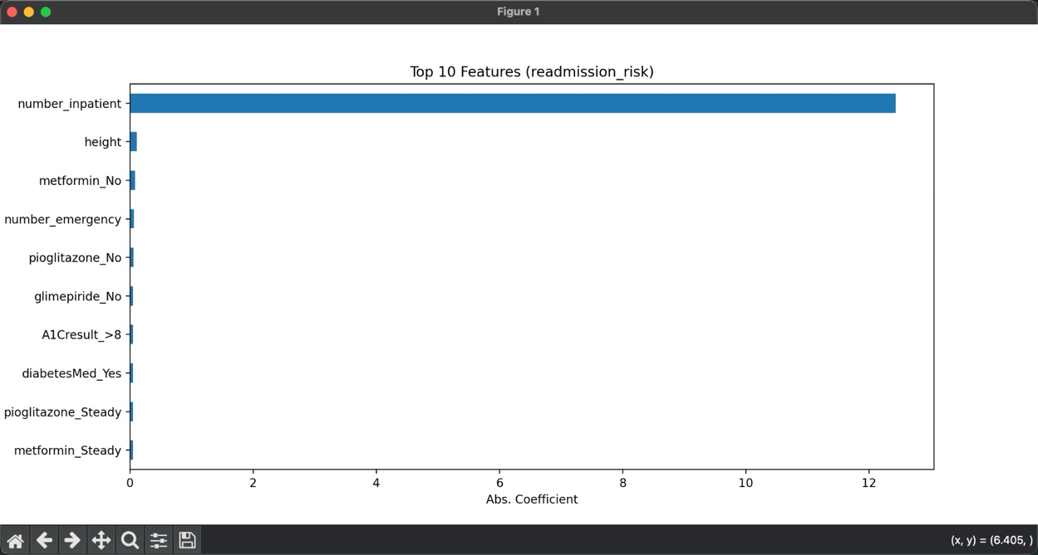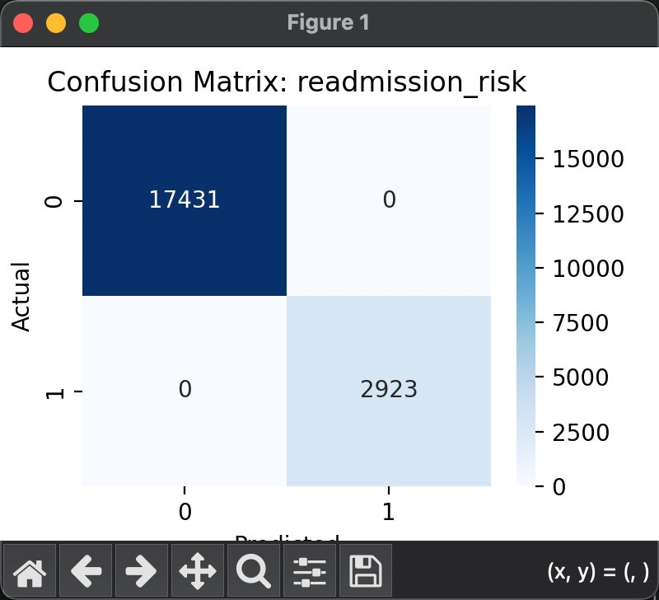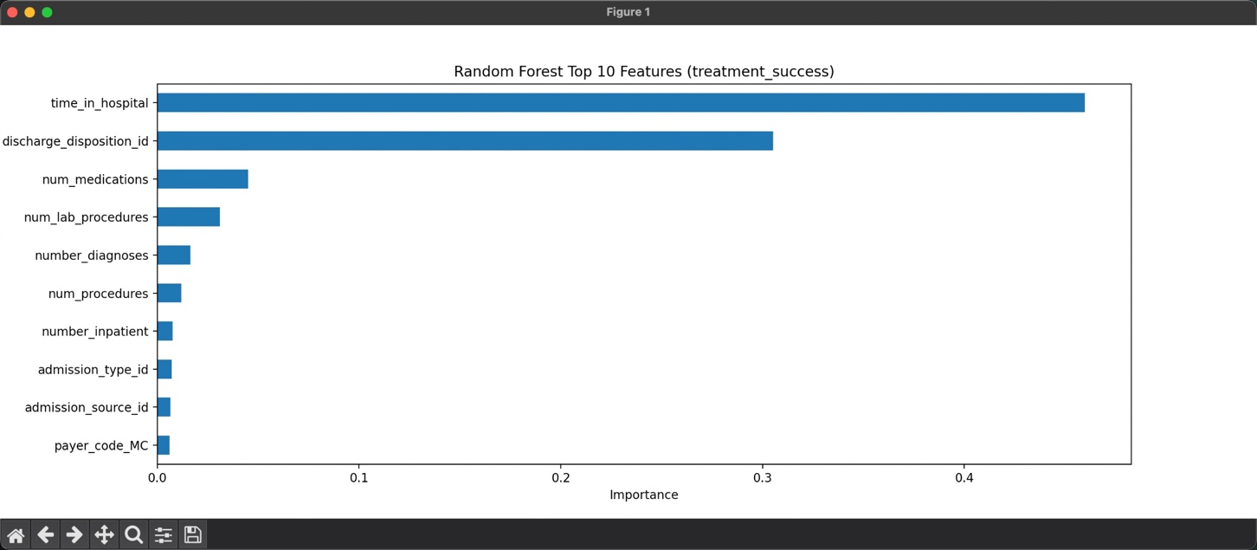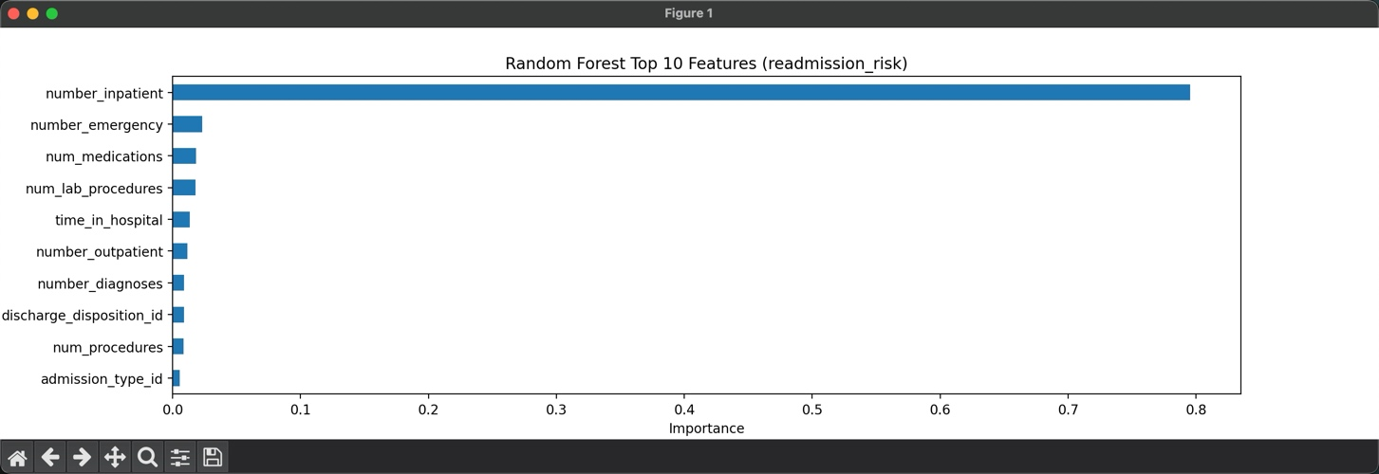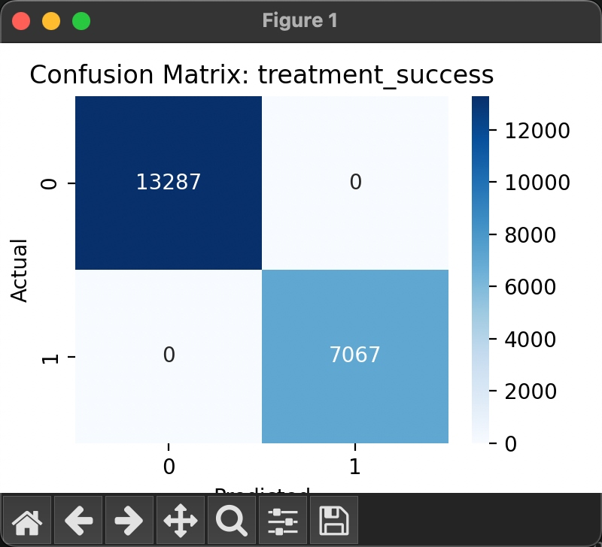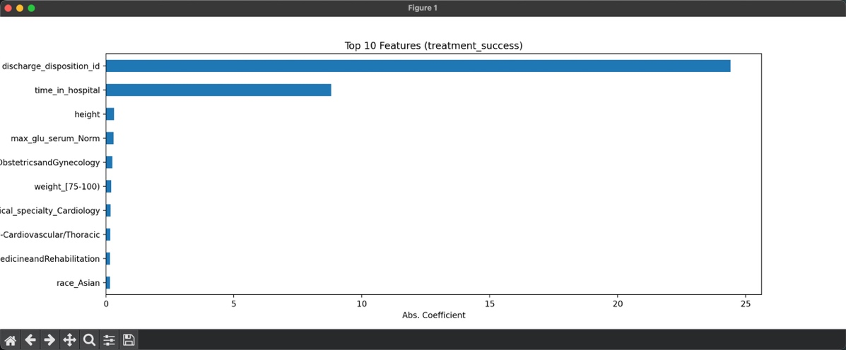

Next Step: Week 6 Plan
Objective:
- Develop interactive dashboards and summary reports for stakeholders.
- Enable practical interpretation and dissemination through dynamic visualizations and anomaly alerts.
Deliverable:
- Interactive dashboard (e.g. built with Streamlit, Dash, Tableau, or PowerBI), featuring:
  - Patient outcome trends over time, specialty, and risk segments
  - Feature importance charts and what-if analysis
  - Anomaly detection alerts for unusual readmission/success rates
- Final project presentation:
  - Slide deck summarizing methods, key findings, model results, and actionable recommendations for clinical/operational teams.
Suggested Actions:
- Prototype dashboard with Python (Streamlit) or BI tool.
- Build at least 3 interactive visualizations:
  - Distribution of outcomes,
  - Feature importance/drivers,
  - Alerts for spikes in risk/success
- Prepare clear presentations (with executive summary and recommendations).

Attachments:
- Modeling code: week5_analysis.py (full pipeline)

